
4th June 2013

Company Announcements Officer
ASX Limited
Exchange Centre
Level 4, 20 Bridge Street
SYDNEY NSW 2000

Dear Sir

Re: major new nickel discoveries at windarra

We enclose herewith a copy of an announcement in relation to the above.

Yours faithfully

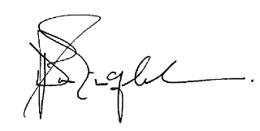
David P.A. Singleton
MANAGING DIRECTOR &
CHIEF EXECUTIVE OFFICER

Enc
CORPORATE DIRECTORY Principal Office
Unit 8, Churchill Court
Director / Senior Management 331-335 Hay Street
David Singleton Managing Director & Chief Executive Officer SUBIACO WA 6008
Andrew Forrest Non-Executive Chairman P: 61 8 9382 8799
Geoff Brayshaw Non-Executive Director F: 61 8 9382 4760
Richard Monti Non-Executive Director
Chris Indermaur Non-Executive Director Registered Office
Ross Kestel Company Secretary Level 2, Spectrum
100 Railway Road
Corporate Enquiries SUBIACO WA 6008
Mr David Singleton – MD & CEO P: 61 8 9367 8133
P: 61 8 9382 8799 F: 61 8 9367 8812
F: 61 8 9382 4760
Media Enquiries
E: admin@poseidon-nickel.com.au Shane Murphy/Jane Munday
FTI Consulting
P: 61 8 9485 8888
Shareholder Enquiries M: 0420 945 291/0488 400 248
Enquiries concerning shareholdings should be addressed to:
Home Exchange
Computershare Investor Securities The Company’s shares are listed
GPO Box D182, Perth WA 6840 on the Australian Securities Exchange
P: 61 8 9323 2000 and the home exchange is Perth
ASX code: POS

ASX Announcement 4th June 2013

Major New Nickel Discoveries at Windarra

Highlights

- Poseidon has discovered large new zones of nickel at its Windarra Project
- The nickel mineralisation has been discovered close to existing mining infrastructure which can increase project production with minimal extra capital cost
- These discoveries are a bonus to the existing positive project economics
- The discoveries could increase planned ore production in the first two operational years from:
  - Substantially thicker and higher grade mineable resource in C Shoot
  - A new potentially mineable resource adjacent to F Shoot and very close to existing underground infrastructure
- Poseidon will now:
  - Update mineral resource and mine plan reports
  - Drill additional untested areas to find similar bonus resources, adjacent to the decline
- WA State Government has extended Poseidon’s current licences for an additional 12 months
Poseidon Nickel Limited (ASX:POS) (“Poseidon” or the “Company”) announces that the Company has received outstanding results from the current drilling programme at Mt Windarra which commenced in November 2012.

These latest drill intercepts are likely to lead to further high grade nickel zones being added to the current Mt Windarra resource which would give the Project significantly more production during the first two operational years at least. Further drilling is underway to determine the extent of the vertical depth of the new zones.

The results, from the expanded C Shoot and newly discovered area, which is adjacent to F Shoot, give additional high grade mineralised zones to the Mt Windarra ore body. These zones could as much as double the size of the estimated mineable ore body in the areas drilled and add very significant tonnages to the overall resources at Mt. Windarra.

Poseidon Nickel Managing Director, Mr David Singleton, said that the results showed that the Mt. Windarra mine still has significant upside with deposits of nickel near to existing infrastructure which can be cheaply revealed with modern technology. Such discoveries will provide a stream of bonuses to the already robust economics of the Project.

“Our discovery cost, prior to this campaign, has been circa 10 cents for every pound of nickel in resources and these drilling results should continue that cost trend.

“I’m particularly pleased with the uncovering of the new, apparently mineable mineralised zone, adjacent to F Shoot. It demonstrates that the detailed insights that our geologists have acquired over the last five years of painstaking work is creating breakthroughs in nickel discovery” said Mr Singleton.

“With these additional high grade zones, we will now move to upgrade both the mineral resources and ore reserves at Mt Windarra, and incorporate these upgrades into our finance model,” said Mr Singleton.

Current Total Mineral Resources at Mt Windarra stand at 3.95M tonnes at 1.73%, for 68,300 tonnes of contained nickel (Current Resources and Reserves at Mt Windarra are detailed further in Appendix 2). Upgrades incorporating these extensions into both the Resource and Reserve calculations are expected to be released in the short term.

Significant drilling results at C Shoot include:

- 10.44m @ 2.22% nickel from 413.31m, within 15.75m @ 1.67% nickel
- 5.58m @ 2.76% nickel from 465.42m, within 10.86m @ 2.05% nickel
- 9.0m @ 2.88% nickel from 393.0m, within 16.7m @ 2.24% nickel
- 10.0m @ 2.66% nickel from 393m.0m, within 19.25m @ 1.84% nickel

At the newly discovered nickel zone, which is adjacent to F Shoot, drilling has been designed to deliver resources of sufficient JORC confidence category to allow immediate conversion to mining reserves. The mineralised zone is approximately 3m in width and currently extends over 350m high by 130m along strike and remains open at depth.

Previously, the C Shoot zone was interpreted as being around 4–5m in thickness, however this recent drilling has demonstrated that C Shoot is 8-9m in thickness on average with a lower grade halo that can expand out to 12-15m thickness in places. This is expected to have positive implications for an increase in resources at Mt Windarra, alongside increases in the JORC confidence category of the resource.

WA State Government Project approvals

Poseidon is also pleased to announce that it has received advice from the WA State Premier, The Hon. Colin Barnett, that permission has been given for an extension to the Project approvals to 30 June 2014 subject only to similar conditions previously announced. In the Company’s opinion, this gives more than ample time for the finalisation of finance for the Project.

The Windarra Nickel Project, located 260 kilometres north east of Kalgoorlie in Western Australia, is destined to be Australia’s newest nickel producer and will be ready to meet expected supply shortfalls in 2014/2015. Poseidon has completed a Definitive Feasibility into the Project, the key highlights of which were recently published. Underground Resources at the Mt Windarra ore body form approximately half of the resource base at the Windarra Nickel Project, alongside the Cerberus ore body.

Poseidon Nickel has engaged Credit Suisse to assist in developing the various alternatives towards financing the Project. Credit Suisse is a major international investment bank which recently led a successful major debt financing for The Fortescue Metals Group (FMG). These enhancements to the Mt Windarra ore body will be included in financing package documentation being prepared.

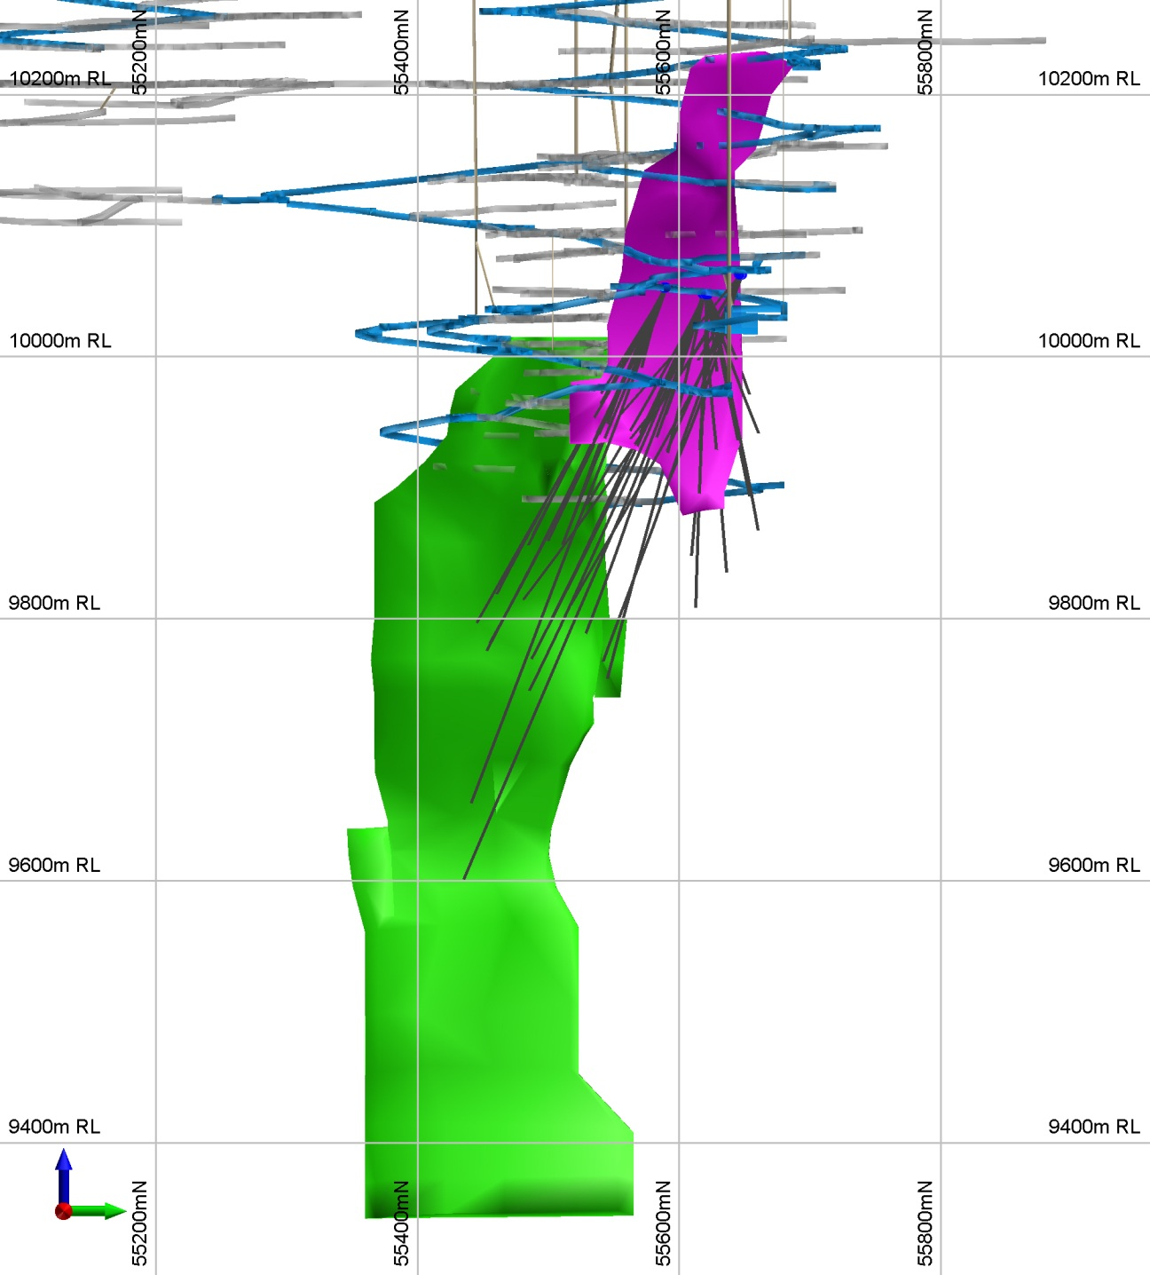
Current holes in progress
F Zone
drilling
C Shoot
drilling
Decline
Crusher chamber
& drill cuddy
C Shoot
F Shoot

C Shoot and F Zone Geological Setting

--ENDS--

For further information, please contact

David Singleton Shane Murphy
Poseidon Nickel Ltd FTI Consulting
Managing Director (08) 9485 8888
(08) 9382 8799 0420 945 291

Appendix 1 – Windarra Drilling Results

Hole_ID | Dip/Azi | From (m) | To  (m) | Interval (m) | True Width  (m) | Ni% | Comment
WUG0012 | -32/245 | 463.74 | 474.60 | 10.86 | 9.37 | 2.05 | C Shoot
WUG0012 | including | 465.42 | 471.00 | 5.58 | 4.81 | 2.76
WUG0013 | -45/248 | 472.00 | 475.72 | 3.72 | 3.10 | 2.02 | C Shoot; Eastern Zone
WUG0013 |  | 480.21 | 483.21 | 3.00 | 2.50 | 1.77 | C Shoot; Western Zone
WUG0013 | including | 482.17 | 483.21 | 1.04 | 0.87 | 3.47
WUG0020 | -36/246 | 144.24 | 147.24 | 3.00 | 2.32 | 1.79 | Orthus Zone
WUG0020A | -42/244 | 408.00 | 423.75 | 15.75 | 12.00 | 1.67 | C Shoot
WUG0020A | including | 413.31 | 423.75 | 10.44 | 7.48 | 2.22
WUG0021 | -46/270 | 163.38 | 171.30 | 7.92 | 5.70 | 1.91 | Orthus Zone
WUG0021 | including | 165.52 | 170.81 | 5.29 | 3.81 | 2.52
WUG0023 | -55/271 | 185.69 | 189.06 | 3.37 | 2.05 | 1.21 | Orthus Hanging-wall
WUG0024 | -40/271 | 149.00 | 160.54 | 11.54 | 8.84 | 1.31 | Orthus Zone
WUG0024 | including | 149.00 | 155.00 | 6.00 | 4.60 | 2.00
WUG0024 |  | 171.14 | 175 | 3.86 | 2.96 | 0.91 | Orthus Zone
WUG0025 | -21/282 | 146.00 | 150.00 | 4.00 | 3.73 | 2.02 | Orthus Foot-wall
WUG0025 |  | 154.00 | 157.00 | 3.00 | 2.80 | 1.57 | Orthus Zone
WUG0025 |  | 210.08 | 213.00 | 2.92 | 2.73 | 2.18 | G Shoot
WUG0028 | -37/246 | 157.14 | 158.81 | 1.67 | 1.33 | 1.38 | Orthus Hanging-wall
WUG0029 | -38/282 | 233.67 | 240.10 | 6.43 | 5.03 | 1.12 | G Shoot
WUG0030 | -45/285 | 248.81 | 254.20 | 5.39 | 3.80 | 2.01 | G Shoot
WUG0031 | -38/245 | 147.15 | 151.74 | 4.59 | 3.62 | 1.38 | Orthus Hanging-wall
WUG0033 | -38/245 | 293.00 | 296.00 | 3.00 | 2.36 | 1.30 | D Shoot
WUG0033 |  | 316.07 | 319.76 | 3.69 | 2.91 | 1.35 | D Shoot
WUG0033 |  | 388.00 | 405.78 | 16.70 | 13.16 | 2.24 | C Shoot
WUG0033 | including | 393.00 | 402.00 | 9.00 | 7.09 | 2.88
WUG0034 | -37/240 | 147.00 | 151.87 | 4.87 | 3.89 | 1.32 | Orthus Hanging-wall
WUG0034 |  | 387.75 | 407.00 | 19.25 | 15.53 | 1.84 | C Shoot
WUG0034 | including | 396.00 | 406.00 | 10.00 | 8.05 | 2.66
WUG0035A | -42/245 | 319.00 | 323.00 | 4.00 | 2.97 | 1.25 | D Shoot
WUG0035A |  | 410.92 | 421.4 | 10.48 | 7.90 | 1.90 | C Shoot
WUG0035A | including | 414.00 | 418.00 | 4.00 | 2.99 | 2.55
WUG0038 | -46/244 | 321.00 | 324.50 | 3.50 | 2.43 | 1.50 | D Shoot
WUG0038 |  | 424.00 | 432.96 | 8.96 | 6.22 | 1.98 | C Shoot
WUG0038 | including | 429.00 | 432.50 | 3.50 | 2.43 | 3.00

Appendix 2 – Windarra Resources and Reserves

Nickel Sulphide Resource Statement as at December 31, 2012
Windarra  Nickel Sulphide  Project | Cut Off Grade | Resource Category – Nickel Sulphides
Windarra  Nickel Sulphide  Project | Cut Off Grade | Indicated |  |  | Inferred |  |  | TOTAL
Windarra  Nickel Sulphide  Project | Cut Off Grade | Tonnes | Ni% Grade | Ni Metal  t | Tonnes | Ni% Grade | Ni Metal  t | Tonnes | Ni% Grade | Ni Metal t
Mt. Windarra | 0.75% | 974,000 | 1.25 | 12,400 | 2,977,000 | 1.88 | 55,900 | 3,951,000 | 1.73 | 68,300
South Windarra | 0.80% | 772,000 | 0.98 | 7,500 | - | - | - | 772,000 | 0.98 | 7,500
Cerberus | 0.75% | 2,773,000 | 1.25 | 34,600 | 1,778,000 | 1.91 | 34,000 | 4,551,000 | 1.51 | 68,600
Total Sulphide |  | 4,519,000 | 1.21 | 54,500 | 4,755,000 | 1.89 | 89,900 | 9,274,000 | 1.56 | 144,400

Table 3: Nickel Sulphide Ore Reserve Statement as at December 31, 2012
Windarra  Nickel Sulphide  Project | Ore Reserve Category – Nickel Sulphides
Windarra  Nickel Sulphide  Project | Probable
Windarra  Nickel Sulphide  Project | Tonnes | Ni% Grade | Ni Metal t
Cerberus | 1,221,000 | 1.30 | 15,880
Mt. Windarra | 326,000 | 1.22 | 4,000
Total Sulphides | 1,547,000 | 1.29 | 19,880

Note: The information in this announcement that relates to Mineral Resources is based on information compiled by Mr N Hutchison, General Manager of Geology at Poseidon Nickel, who is a Member of The Australian Institute of Geoscientists and Mr I Glacken who is a Fellow of the Australasian Institute of Mining and Metallurgy as well as a full time employee of Optiro Pty Ltd.

The information in this announcement that relates to Ore Reserves is based on information compiled by Denis Grubic, who is a Member of The Australasian Institute of Mining and Metallurgy as well as a full time employee of Rock Team Pty Ltd.
Mr Hutchison, Mr Glacken and Mr Grubic all have sufficient experience which is relevant to the style of mineralisation and type of deposits under consideration and to the activity which they are undertaking to qualify as a Competent Person as defined in the 2004 Edition of the ‘Australasian Code for Reporting of Exploration Results, Mineral Resources and Ore Reserves.’ Mr Hutchison, Mr Glacken and Mr Grubic have consented to the inclusion in the report of the matters based on his information in the form and context in which it appears.

The Australian Securities Exchange has not reviewed and does not accept responsibility for the accuracy or adequacy of this release.

Disclaimer

This announcement contains certain “forward-looking statements”. These forward-looking statements are based on the beliefs of Poseidon's management as well as assumptions made by and information currently available to Poseidon's management, and speak only as of the date of this announcement. Forward-looking statements involve known and unknown risks, assumptions, uncertainties and other important factors that could cause Poseidon’s ability to complete and commission the project, its actual results, performance or achievements, or industry results, to differ materially from any future results, performance or achievements expressed or implied by such forward-looking statements (and from past results, performance or achievements). These forward-looking statements include, but are not limited to, all statements other than statements of historical facts, including, without limitation, statements regarding completion of the project, estimated resources and reserves, plans, strategies and objectives of management, anticipated production or construction commencement dates, expected costs and production outputs, EBITDA and other expected financial results, rates of return or net present values, outlook, and anticipated productive lives of projects and mines. In some cases, you can identify forward-looking statements by terminology such as, “aim,” “anticipate,” “assume,” “believe,” “continue,” “could,” “estimate,” “expect,” “forecast,” “intend,” “may,” “objectives”, “outlook,” “plan,” “potential,” “predict,” “project,” “risk,” “should,” “target”, “will” or “would” or the negative of such terms or other comparable terminology and other similar expressions that are predictions of or otherwise indicate future events or trends. Poseidon can give no assurance that the forward-looking statements in this presentation will not materially differ from actual results, and the inclusion of forward-looking statements in the announcement should not be regarded as a representation by Poseidon or any other person that they will be achieved.

In addition, the assumptions and estimates underlying the expected financial results included in this announcement are inherently uncertain and are subject to regulatory, business and economic risks and uncertainties that could cause actual results to differ materially from those contained in this announcement. You should be aware that the timing of events and the magnitude of their impact might differ from that assumed in preparing the expected financial results, and that this may have a material positive or negative effect on our financial performance and the financial performance of the project.

